AIM:- To perform Boats-Sailors Database.

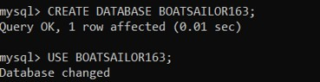**Sailors (sid, sname, rating, age) Boats (bid, bname, color) Reserves (sid, bid, day) DATABASE CREATION**

**BOATS TABLE CREATION**

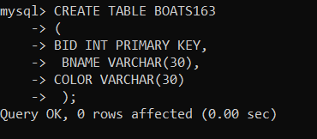

**VALUES INSERTION IN BOATS TABLE**

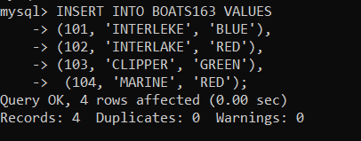

**DISPLAY BOATS TABLE**

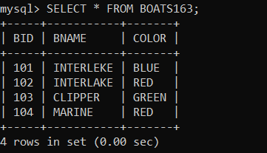

**DESCRIBE BOATS TABLE**

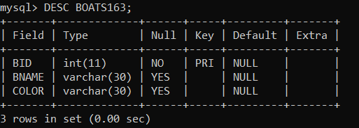

**SAILORS TABLE CREATION**

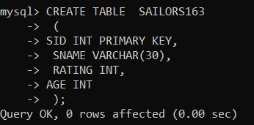

**VALUES INSERTION IN SAILORS TABLE**

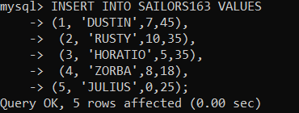

**DISPLAY SAILORS TABLE**

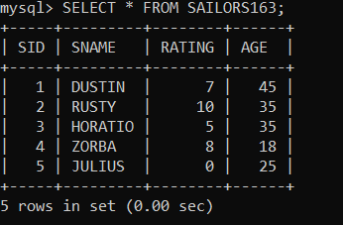

**DESCRIBE SAILORS TABLE**

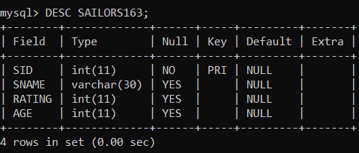

**RESERVES TABLE CREATION**

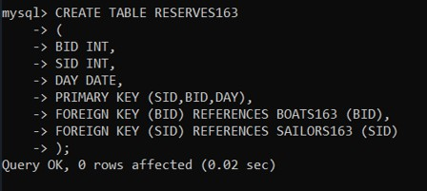

**VALUES INSERTION IN RESERVES TABLE**

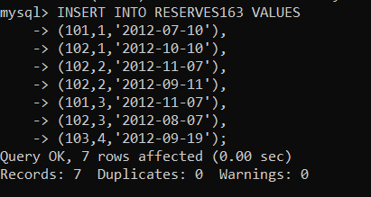

**DISPLAY RESERVES TABLE**

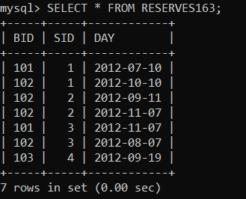

**DESCRIBE RESERVES TABLE**

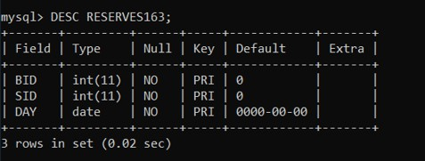

**AIM:- To perform all queries of the Boats-Sailors database.**

1. **List names of boats.**

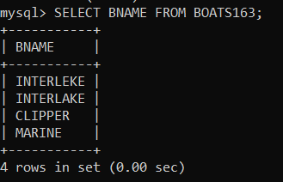

1. **List ratings and ages of sailors.**

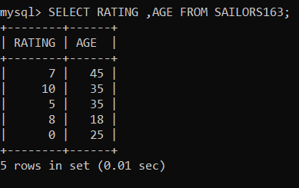

1. **List name of sailors who are over 21 year old.**

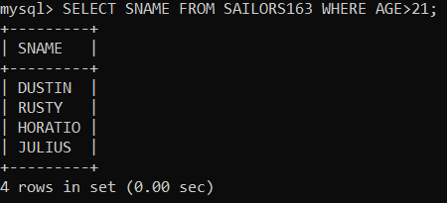

1. **List names of red boats.**

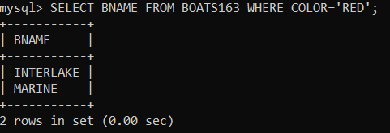

1. **List ids of boats that have ever been reserved.**

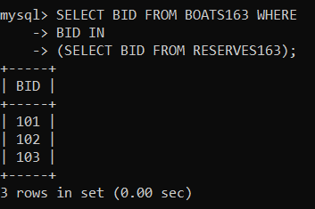

1. **Find the color of a boat name clipper.**

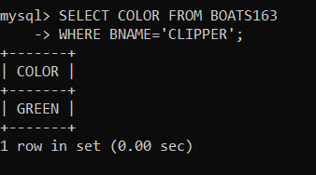

1. **Find all sailors who are 35 or older, sort them by name.**

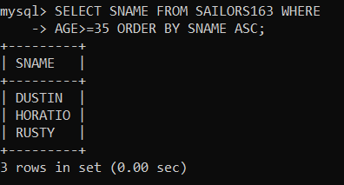

1. **List all names of red boats, sorted by boat id.**

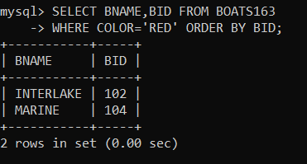

1. **Find all boats that are either red or called interlake.**

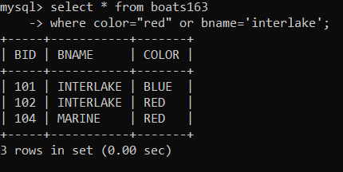

1. **Find names, sid of sailors whose rating * 5 is less than their age.**

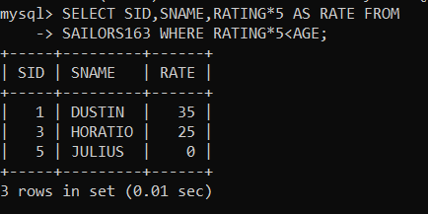

1. **Find names, sid of sailors whose name contain the letter u.**

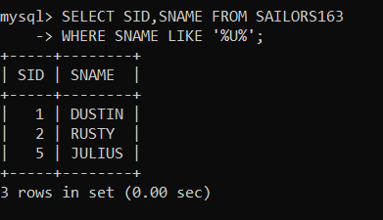

1. **Find names of sailors who have reserved a red boat.**

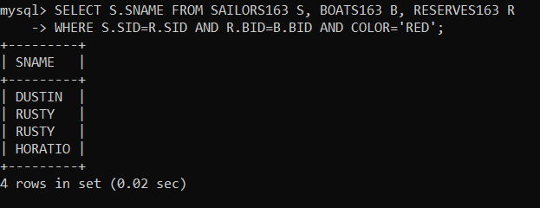

1. **Find names of sailor who have reserved boat 101.**

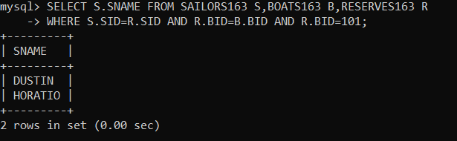

1. **Find unique ages of sailors who have reserved a red boat.**

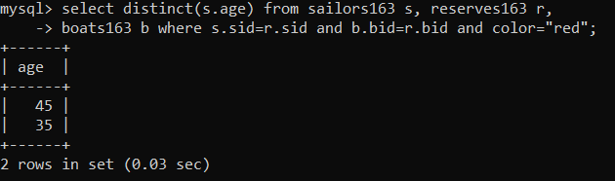

1. 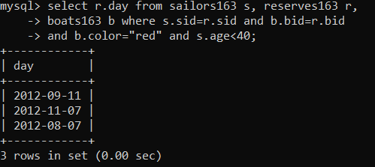**Find days of reservation made for the red boat by a sailor who is under 40 years old.**
2. **Find unique ids & names of sailors who have reserved a red or a blue boat.**

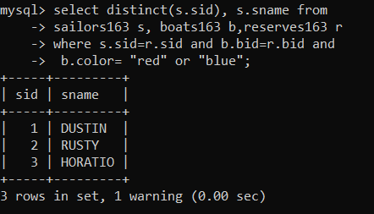

1. **Find unique sids & names of sailors who have reserved a red & blue boats.**

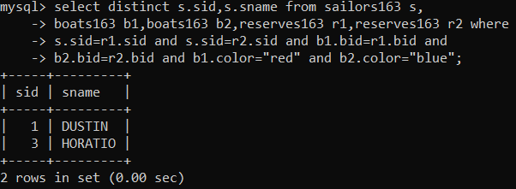

**AIM: To perform the queries of Boats-Sailors database.**

1. **Find sids of sailors who have reserved a red but not a blue boat.**

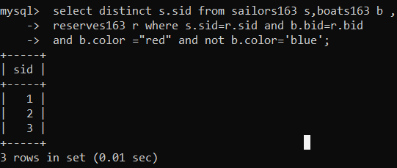

1. **Find unique bids of boats that have been reserved by sailors with rating>7.**

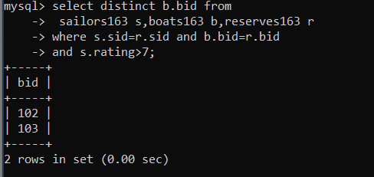

1. **Find unique bids of boats that have been reserved by sailors with rating>7 or <5.**

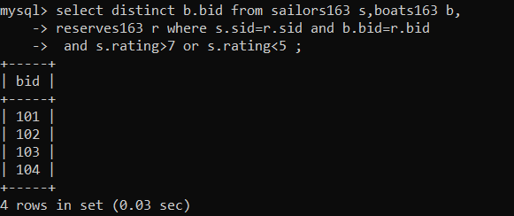

1. **Find unique bids of boats that have been reserved by sailors with rating>7 and**

<5.

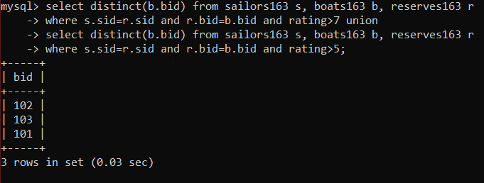

1. **Find unique bids of boats that have been reserved by sailors with rating>7 but not <5.**

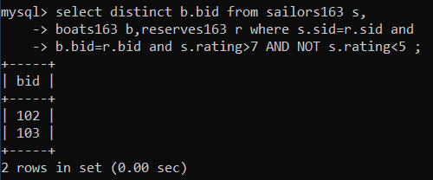

1. **Find unique names of boats that were reserved during the month of october.**

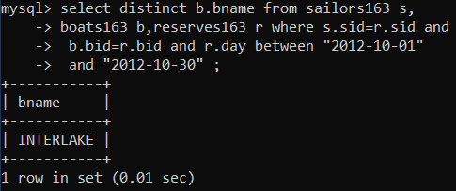

1. **Find names of sailors who have never reserved a red boats.**

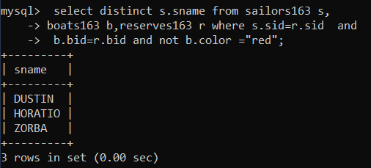

1. **Find the average age of sailors with a rating of 10.**

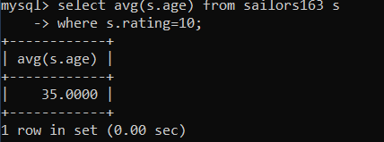

1. **Find the number of sailors.**

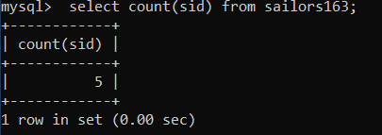

1. **Find names and age of oldest sailors.**

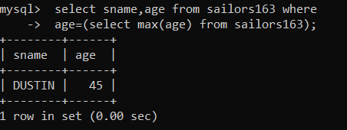

1. **List sids, names of sailors with an above average rating.**

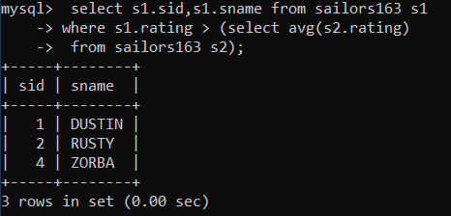

1. **Find the age of the youngest sailors for each rating level.**

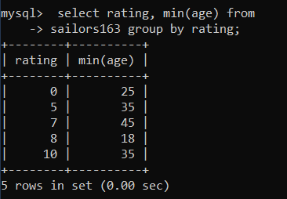

1. 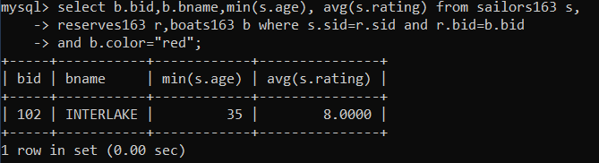**Find bid, name of each red boat that has been reserved along with an average rating and minimum age of sailors who have reserved that boat.**
2. **Find the number of boat reservations by each sailor who is at least 20 years old.**

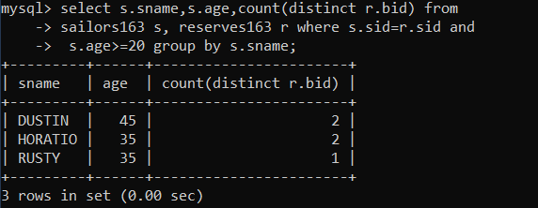

1. 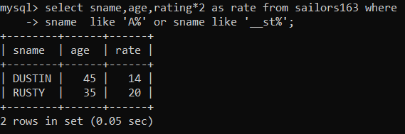**Find age 2* rating of all sailors whose name start with ‘A’ or contain as substring starting from position 3.**
2. 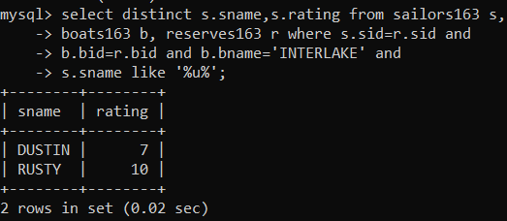**Find unique names and rating of sailors who have reserved a boat named ‘Interlake’ and whose name contains the letter ‘u’.**
3. 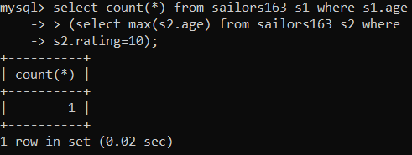**Find the number of sailors who are older than the oldest sailor with the rating of 10.**